**HTML MANUAL**

TABLE OF CONTENTS

1. General Web Overview

2. Getting Started With HTML

3. Tags/Elements

4. Headings and Paragraphs

5. List: Ordered and unordered list & Tables

6. Div/section/header/nav/footer/span tags

7. Hr(horizontal rule) and Br(line break) and Mapping Path (..)

8. Links with Anchor tag

9. Image and Video with local and external sources

10. Explaining HTML Symbols

11. Forms

# Chapter 1: GENERAL WEB OVERVIEW

**What is WEB ?**

This is a collection of documents hosted on a server, accessible via the internet over http protocol.

Web, or World Wide Web (www) as it is more often referred to, is a network of computers and similar web-enabled gadgets that communicate over the internet via the http protocol.

These websites are hosted on powerful computers called servers. A server is a normal computer except that it is equipped with more CPU, RAM and specialized operating system for heavy loads.

While the word server refers to the computer hosting the website, client refers to any device (desktop, laptop, phone etc) consuming the website.

**Terminologies**

***Website (static)***

This is just an online brochure that explains what a given outfit does. E.g company's website, personal portfolio site etc.

***Web App(dynamic)***

This a tool that gets certain task/work done. Which normally have: Frontend and Backend

* Frontend(html & css, js[optional])
* Backend (serverside language[php,java,python, .net etc] + database)

Web is a network of computers or similar gadgets that communicates over the internet via the http protocol.

Web is any piece of software/component/gadget that communicates over http protocol.

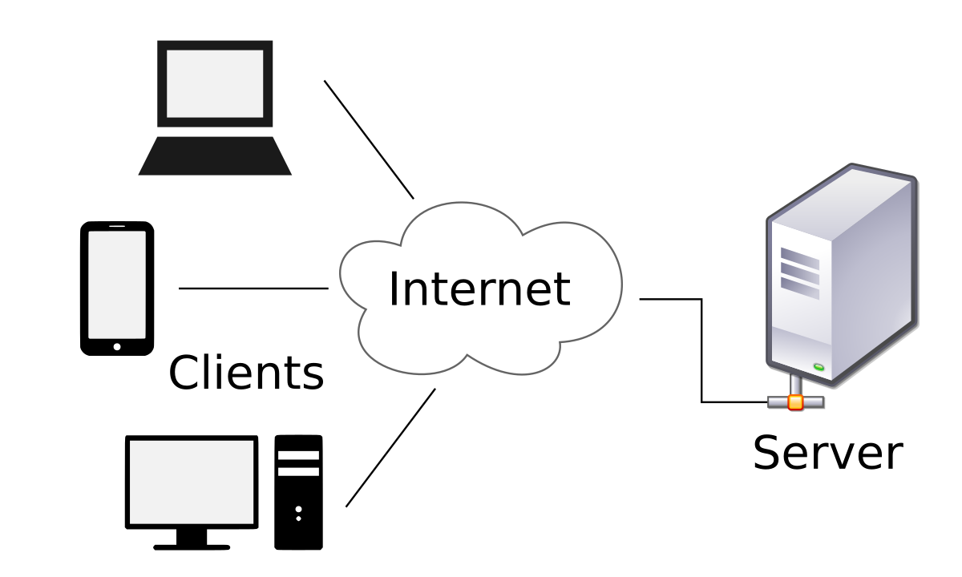

**Kinds Of Applications**

- GUI/Desktop app : Ms Suite, Photoshop, Coreldraw

- Web App : facebook,instagram client-server architecture

- Mobile App: facebook, instagram

- CLI (Command Line Interface ... black screens no user interface)

***QUESTION***

*What is the difference between Website and Web App and Web ?

**HOW THE WEB WORKS: REQUEST & RESPONSE CYCLE**

To master web development, it is important to fully understand how the web works. All web interactions start with the user’s **http request** and ends with **http response**.

*Http* : HyperText Transfer/Transport Protocol: is defined a web communication protocol.

*FTP* - File Transfer Protocol.

*URL:* www.google.com

Domain Name: is a convenient naming system on the internet for easy IP reference. IP(Internet Protocol) is the number reference or address of every server on the internet

*Web based apps:* This use client-server architecture.

For every web request, http request is made to the server, the server processes and sends back an http response.

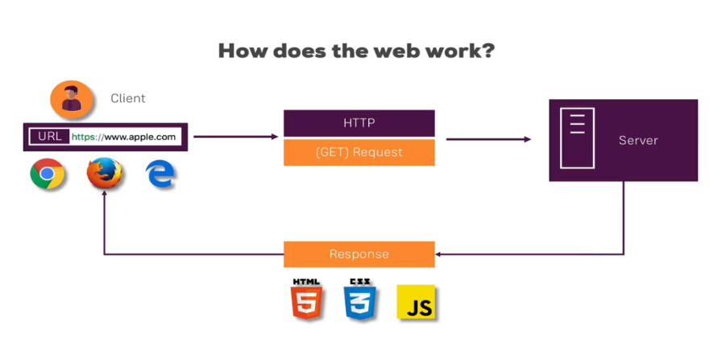

As can be seen from the illustration above, the following steps are involved in every request-response cycle:

* The user enters a url (www.anchorsoftng.com) in the browser. This is sent as a http request to the server hosting the website/webapp. The request is also sent as a *GET request http method.* More detail about other http methods shortly.
* The server interpretes it to know what resources (html , pdf, database content etc) the user is requesting; the server sends back http response to the client.
* The client, usually a browser gets the response, which is usually html page,css and javascript.

**Web Page Construction**

To build a web page we use: html, css(cascading style sheet) and javascript.

*HTML (HyperText Markup Language):* we use this to markup our web page. To markup means to use the right tag for the right content type.

File protocol is not meant for web operations. The web is designed to use http protocol.

Html is composed of Elements/Tags

p - paragraph

a - links

img - Image display

**Code Editor**

Professional developers  use professional code editors like **VS Code for productivity**.

Download vs code at <https://code.visualstudio.com/download>

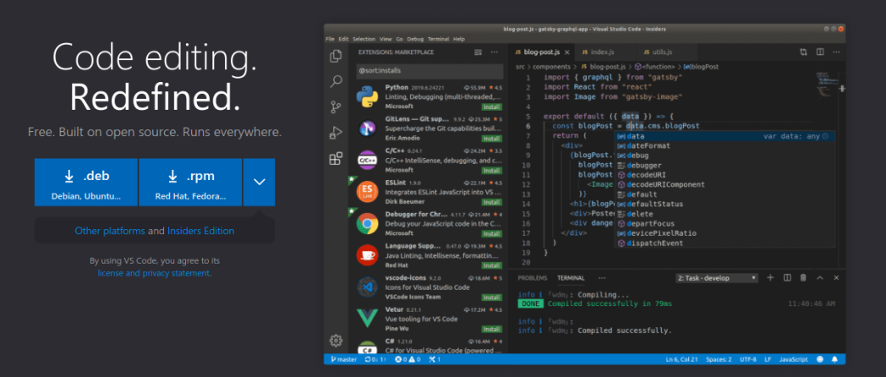

**LIVE SERVER**

You will also want to install the live server vs code plugin to be able to run you html files with an http based server:

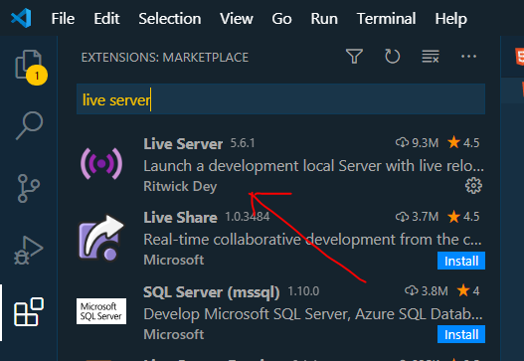

**Different File Extensions**

mynote.doc - this is a microsoft document.

mynote.txt - this is a text file document.

index.html - this is a web document.

***QUESTION***

*What is the file extension of a web document ?

**2. GETTING STARTED WITH HTML**

**What is HTML ?**

* HTML stands for **Hyper Text Markup Language**
* HTML is used to define the content of webpages.
* HTML describes the structure of a Web page contents
* HTML consists of a series of **elements/tags**.
* These elements tell the browser how to display the content

**HTML ELEMENT**

HTML stands for **Hyper Text Markup Language**

A web is created by using various html elements, also known as tags, to create various content types in the document.

Below is how html elements are created:

**<tagname>Content here</tagname>**

|  |  |  |
| --- | --- | --- |
| **Start Tag** | **Content** | **End Tag** |
| <title> | HTML 101 | </title> |
| <h1> | Setting paces | </h1> |
| <br> | none | none |

<title> HTML 101</title>  
<h1>Setting paces</h1>

<br>

Every first page/welcome page of a web application is always known as the INDEX page and save as index.html

# WEB PAGE CONSTRUCTION

* Html, CSS and Javascript are used to construct web pages.
* The diagram below shows how the trio are connected to create a web page
* A web page is called a html document.

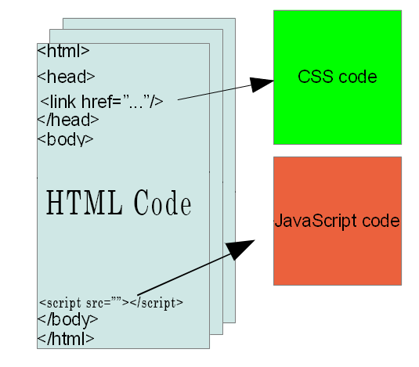

A Sample HTML Code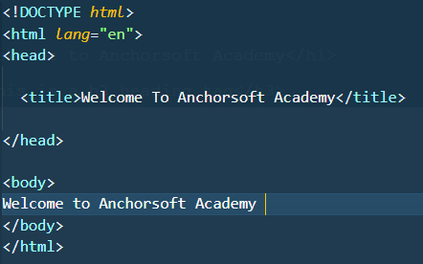

Result In The Web Browser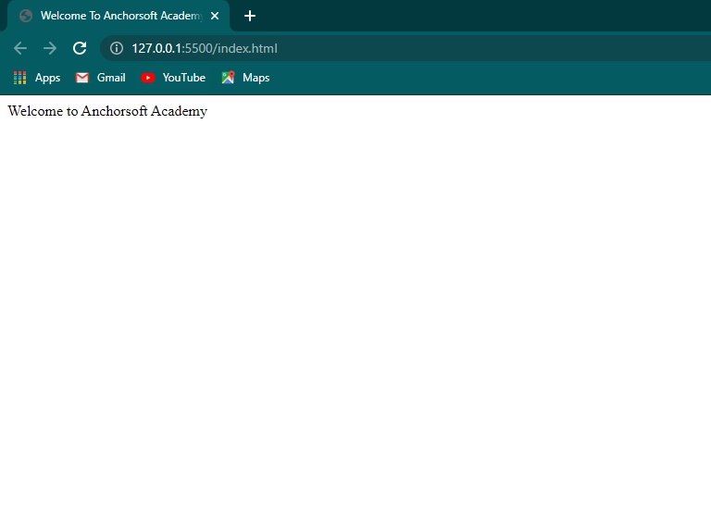

**<!DOCTYPE html>**

This define the type of html document and always start with an exclamation mark(!) i.e; HTML3, HTML4,HTML5

**<html lang="en">**

This is the root tag of our document and body everything else

**<head>**

This is extra information about the web page ; meta , title,links etc and those not get render to the browser

**<title>** Welcome To Anchorsoft Academy **</title>**

This get display at the menu tab of the browser

**</head>**

**<body>**

This is what get render to web browser

**Welcome To Anchorsoft Academy**

**</body>**

**</html>**

***CLASS TO-DO***

* Build your first web template *

**3. TAGS/ELEMENTS HEADINGS AND PARAGRAPHS**

**XHTML and HTML5 Syntax**

This a collection of tags, also called elements/node:

-most html tags have opening and closing tag: <p> contents </p>;

The first<p> is an opening tag and the second </p> is a close tag and always have (/) forward slash

- html with no closing tag: <img>, <br>, <hr> etc

**Block And Inline Level Tags**

We use html tags(elements, DOM - document object model) to construct web pages.

*Block Level Tags*

Block level elements are elements that occupy 100% width of the web page, pushing sibling elements to the next line. e.g: <p>..</p>, <h1>...</h1> etc

*Inline Level Tags*

This is the opposite of block level tag they only occupy the width of the content <span>..</span>, <strong>..</strong>, <em>..</em> etc.

However, the level tags can be changed using the CSS (Cascading Style Sheet)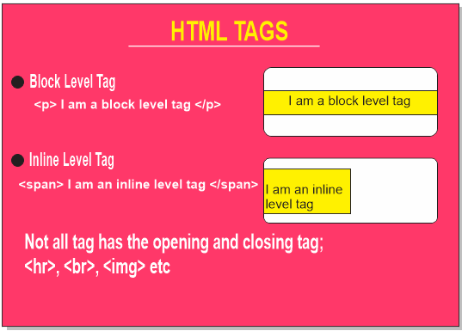

***QUESTION***

*What are block level and Inline level Tags?

**4. HEADINGS AND PARAGRAPHS**

Headings: we use it to markup headings content on web pages. It consists h1 to h6

<h1> i'm heading one</h1>

 <h2> i'm heading two</h2>

 <h3> i'm heading three</h3>

 <h4> i'm heading four</h4>

 <h5> i'm heading five</h5>

 <h6> i'm heading six</h6>

Paragraphs: this is the paragraph tag. We use it to markup paragraph content on web pages.

  <p>Hello! i'm a paragraph</p>

Result in the Browser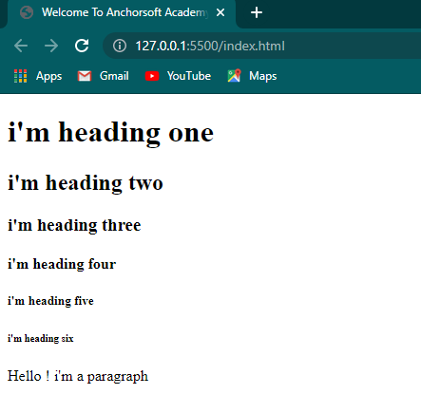

**5. LIST: ORDERED AND UNORDERED LIST & TABLES**

===========================

Unordered and Ordered list are both wrappers for a list tag and is used for marking up listed items; like navigation menu.

ul - unordered list

ol - ordered list.

li - list item

**Unordered List**

<p>List of browser</p>

<ul>

  <li>UC Browser </li>

  <li>Firefox</li>

  <li>Safari</li>

  <li>Webkit</li>

</ul>

**Ordered List**

<p>List of fruits</p>

<ol>

  <li>Apple</li>

  <li>Mango</li>

  <li>Pawpaw</li>

  <li>Orange</li>

</ol>

**Table**

This is mostly use to display data just like the ordered and unordered list but in a tabular form. It consist of table row <tr></tr>, table head <th></th>, table data <td></td>.

<table border="1">

    <thead>

      <tr>

        <th>Name</th>

        <th>Age</th>

        <th>Sex</th>

      </tr>

    </thead>

    <tbody>

      <tr>

        <td>Anchor Soft</td>

        <td>30</td>

        <td>Male</td>

      </tr>

    </tbody>

</table>

Result in browser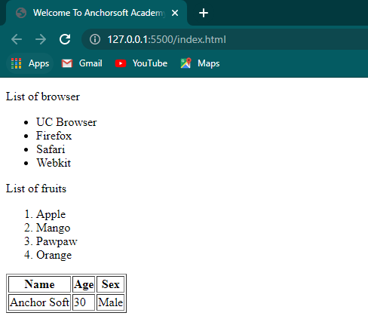

***CLASS TO-DO***

* Build a web page having

-- headings(h1 to h6)

-- paragraph

-- list items

-- table with colspan and rowspan

**6. DIV / SECTION / HEADER / FOOTER /SPAN TAGS**

These are the tags we normally use to section/segment our pages. they are used as layout elements. They can be used for main layout or small containers.

**Div Tag**

This is an element we use as small containers. Container meaning it can house other elements

<div> *<!-- this is a div container -->*

  <ol>

    <li>Apple</li>

    <li>Mango</li>

  </ol>

</div>

**Section Tag**

This is used to create sections for your page. a section is the biggest of all containers, and can contain as many elements as required.

 <section> *<!-- this is a section container -->*

  <ol>

    <li>Pawpaw</li>

    <li>Orange</li>

  </ol>

</section>

**Header Tag**

This also another container element, used to create a top large region at the top of your front page.

<header>

  Home | About | Contact us

</header>

**Footer Tag**

This also another container element, used to create a bottom large region at the bottom your front page.

<footer>

  Copyright 2021

</footer>

**Span Tag**

This is a bit more like a paragraph tag but not a block level element like a paragrap tag and can be used to group element for styling.

<span> I'm a span tag, you can use me anywhere</span>

Result in the browser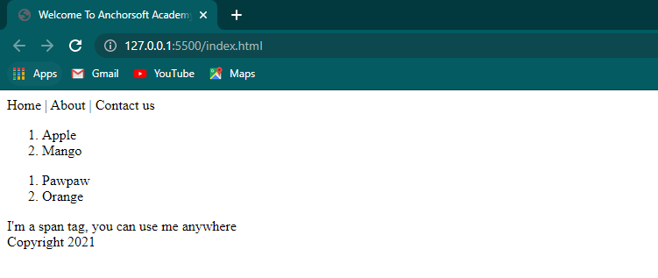

***CLASS TO-DO***

* Build a web page having*

-- Header (explaining nav with SPAN, not list item and anchor tag)

-- Div (wrapping similar elements: e.g Welcome To My Shopping Mall)

-- Section (wrapping Paragraph and lorem text)

-- Footer (paragraph with a copyright text)

NB: The main purpose of this is so they understand sections and layout and adding

Comments to a web page to make code readable and reusable.

**7. LINKS WITH ANCHOR TAG**

Anchor tag is what we use to link pages. It is traditionally called hyperlink.

  <h3>Some Anchor Tag</h3>

  <a *href*="https://www.google.com/" *target*="_blank">Google</a>

  <a *href*="index.html">Home</a>

  <a *href*="about.html">About Us</a>

  <a *href*="contact.html">Contact Us</a>

Result in the browser

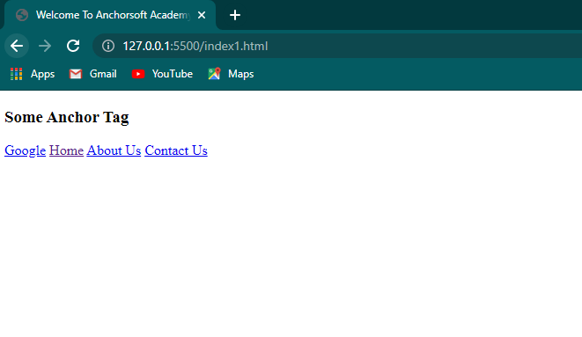

**8. HR(HORIZONTAL RULE) AND BR(LINE BREAK) AND MAPPING PATH (..)**

***Br***

This is called line break. We use it to break a line to the next line.

 <p> I want to tell you a short story but not on one line ***<br>*** thanks br i'm in another line </p>

***Hr***

This is used to draw a horizontal line across the page.

 <p> I want to tell you a short story but not on one line <br> thanks br i'm in another line </p>

***<hr>***

 <p>haaa! hr just caused a demarcation between the two paragraphs </p>

***Mapping Path***

This is used to step out of a folder. We use as many 2-dots to step out/in of any number of folders

<a *href*="../boots/">I used the .. to locate my boots folder</a>

Result in the browser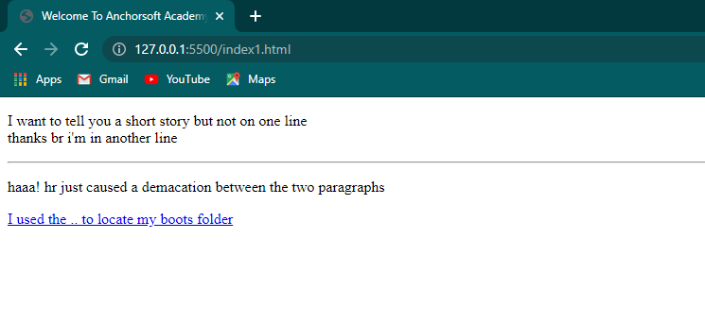

**9. IMAGE, AUDIO AND VIDEO WITH LOCAL AND EXTERNAL SOURCES**

**Image Tag**

This is what we use to add image content on web pages:

There are 4 kinds image type you can use in web development

*- png:* logos and images with flat colors, and with transparent background (logos and graphic contents with flat colors).

*- jpg:* photograph or images with gradient color (for pictures)

*- gif:* web animation (framebyframe animation)

*- svg:* vector based images on web pages.

<p> See image </p>

<img *src*="logo.png" *height*="240" *width*="320" *alt*="anchorsoft logo" />

*Working with image attributes*

*src=""* : This is the source of where the image comes from either local or external

*alt=""* : This is just like a place holder, incase no image is available

***Audio Tag***

This is what we use to add audio content on web pages:

<h5> THE AUDIO </h5>

<audio *controls*="controls">

<source *src*= "ice.mp3" *type* ="audio/mpeg">

</audio>

<audio src="">

</audio>

***Video Tag***

This is what we use to add video content on web pages:

<h5> THE VIDEO </h5>

<video *src* ="fs.mp4"  *autoplay loop* *height*="240" *width*="320">

</video

There are several kinds of video format you can use in web development

- mp4

- avi

- ogg

- flv

- mkv

Result in the browser

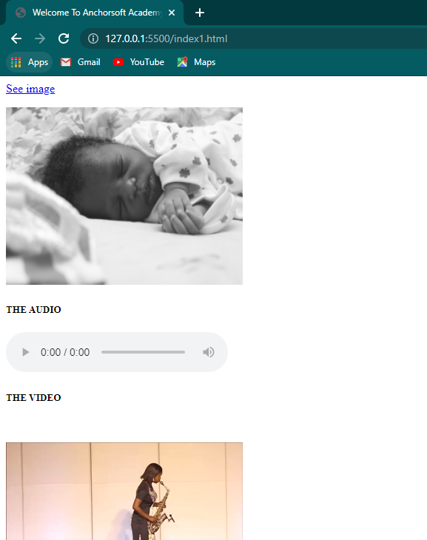

***CLASS TO-DO***

* Build a web page having*

-- several html files, index,about,contact etc

-- Anchor tag to link each of the pages using <SPAN>, we will later explain using list

-- Hr for decorations and br for breaking text/paragraph

-- Images, Audio, video on a page(locally and externally)

-- Clicking a link to navigate to see full image with target="_blank"

**10. EXPLAINING HTML SYMBOLS**

visit the site below and show student symbols and how they can use it in their codes

https://www.toptal.com/designers/htmlarrows/arrows/

E.g: we can write symbols in different ways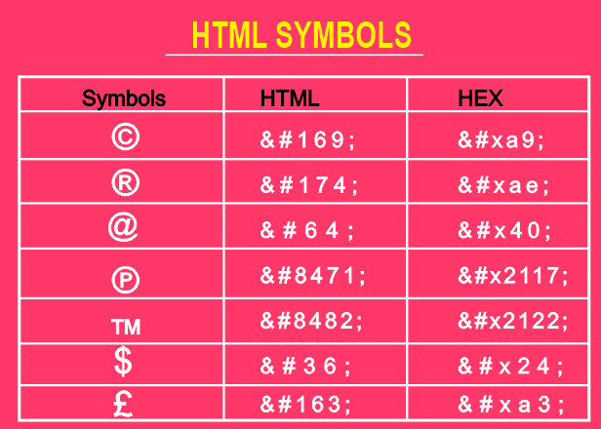

**11. FORMS AND FORM FIELDS**

**Forms**

 <form *action*="" *method*="">

 </form>

* **action:** points to the url that will process the submitted data.
* **method**: this is the http method we want to use to submit the form.
  + - **GET:** this is when we want to retrieve info from the server.
    - **POST:** this is used when we want to save the entered data in the db
    - **PUT/PATCH:** this is used when making a update to an existing resource
    - **DELETE:** to remove a resource from the db

When the method is not indicated in the form, the default is GET. But when you want to save the data in the DB, you have to use the POST method.

*NB: the 'name' attribute*

name attribute is used to reference a tag to the name. But in form elements like radio and checkbox, name attribute is also used to group a set of elements/tags

**Form Fields**

This has attributes like placeholder, required, hidden, disabled, name, id, type etc

1. Label :  <label *for*="">Enter First Name</label>

2. Input : <input *type*="text" *name*="" *id*="">

       <input *type*="email" *name*="" *id*="">

       <input *type*="number" *name*="" *id*="">

 <input *type*="date" *name*="" *id*="">

      <input *type*="file" *name*="" *id*="">

      <input *type*="password" *name*="" *id*="">

      <input *type*="radio" *name*="" *id*="">

      <input *type*="reset" *name*="" *id*="">

      <input *type*="checkbox" *name*="" *id*="">

      <input *type*="button" *name*="" *id*="">

      <input *type*="hidden" *name*="" *id*="">

      <input *type*="range" *name*="" *id*="">

      <input *type*="week" *name*="" *id*="">

      <input *type*="submit" *name*="" *id*="">

3. Button : <button *type*="submit"></button>

4. Select :  <select *name*="" *id*="">

         <option *value*="">1</option>

         <option *value*="">2</option>

        <option *value*="">3</option>

       </select>

5. Text Area: <textarea *name*="" *id*="" *cols*="30" *rows*="10">

          </textarea>

**A Simple Form**

 <h3>A simple Html Form</h3>

  <form *action*="" *method*="get">

    <label *for*="">Enter Full name</label>

    <input *type*="text" *name*="" *id*="">

  <br><br>

    <label *for*="">Enter Email</label>

    <input *type*="email" *name*="" *id*="">

  <br><br>

    <label *for*="">Enter Phone</label>

    <input *type*="number" *name*="" *id*="">

  <br><br>

    <label *for*="">Enter Date of Birth</label>

    <input *type*="date" *name*="" *id*="">

  <br><br>

    <label *for*="">Select Gender</label>

    <input *type*="radio" *name*="" *id*=""> Male

    <input *type*="radio" *name*="" *id*=""> Feale

  <br><br>

    <label *for*="">Select Value</label>

    <select *name*="" *id*="">

      <option *value*="">1</option>

      <option *value*="">2</option>

      <option *value*="">3</option>

    </select>

  <br><br>

    <label *for*="">Message</label>

    <textarea *name*="" *id*="" *cols*="30" *rows*="10">

      Enter some text here

    </textarea>

  <br><br>  <button *type*="submit">Submit</button>

  </form>

Result in the browser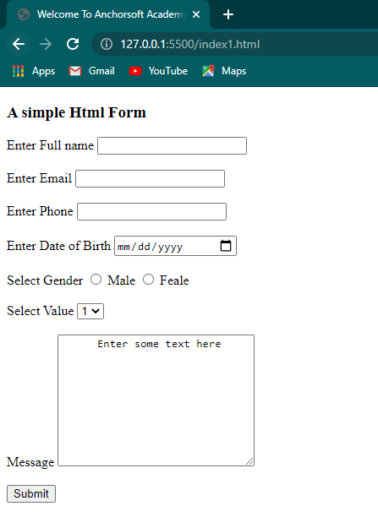

***CLASS WORK***

*Build a web page having*

-- Form in 3 sections

-- Text input section

-- Selection Element section

-- Input-style Button section

NB: The Instructor should make a round check on the CLASS WORK and Then Implement it for other student that might be needing the source code